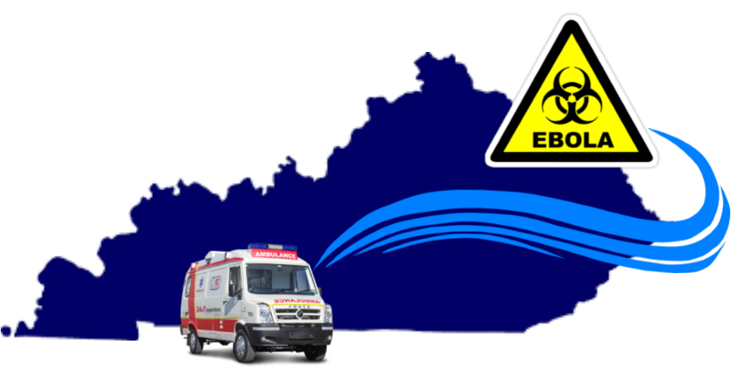

Bluegrass Ebola Response
  - Nov. 13th 2019
AFTER ACTION REPORT
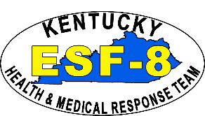
The After-Action Report/Improvement Plan (AAR/IP) aligns exercise objectives with the Hospital Preparedness Program (HPP) Implementation Guidance for Ebola Preparedness Measures and HPP Core Capabilities. This report is intended for exclusive use of exercise planners, exercise participants, observing agencies and associated ESF-8 stakeholders. Exercise information required for preparedness reporting and trend analysis is included. Report recipients are encouraged to contact listed point of contacts for further information and dissemination of report contents.

THIS PAGE IS INTENTIONALLY BLANK

Executive Summary
On November 13th, 2019 University of Kentucky (UK) Medical Center participated in a full scale Ebola Transport Exercise. At approximately 9:00 am on Nov. 13th a suspected Ebola patient arrived at the UK Healthcare Emergency Department ambulatory admitting area and gave a brief travel history and described symptoms of a suspected Ebola patient. UK admitting staff quickly isolated the patient and notified their Infection Prevention and Control department of the suspected Ebola Virus disease patient. UK administration staff activated their Emergency Operations Center (EOC) and incident command staff notified the Regional Epidemiologist at the Lexington Fayette County Health Department (LFCHD). The patient was admitted and kept isolated in the Emergency Department (ED) until maintenance and clinical staff could ready an infectious disease isolation room in the Intensive Care Unit (ICU). At 10:20 a.m. the patient was moved upstairs at UK where lab specimens were drawn and a clinical assessment was performed.

Lab specimens were drawn from the patient, packaged and readied for delivery to the State Lab in Frankfort for testing. At 10:00 a.m. a phone call was held with the Epidemiologists at the LFCHD to give patient information. The Lexington Fayette County Epidemiologists notified the State Health Operations Center (SHOC) of UK’s suspected Ebola patient. UK was then notified a joint phone call would occur at 11:00 am with LFCHD, Kentucky Department for Public Health (KDPH) and the federal Health and Human Services (HHS) Regional Emergency Coordinator (REC). Transportation of lab specimens and time compression of lab results was simulated due to time frame of exercise play.

At 11:00 am, during the joint phone call with UK, LFCHD, KDPH and the REC for HHS, lab results confirmed the patient tested positive for the Ebola virus and would need to be transported to the Ebola Treatment Center at Emory University Hospital in Atlanta. The HHS Regional Coordinator informed clinical staff that if this were a real world incident transportation coordination would require additional logistic phone calls to confirm transport times and patient movement.

The following critical elements were required by Ebola Assessment Hospitals and EMS crews. (Reference: Hospital Preparedness Program (HPP) Measure Manual: Implementation Guidance for Ebola Preparedness Measures – July 2015)
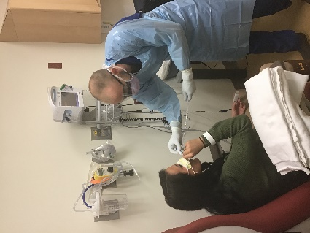
- Time in minutes it took UK Medical Center to identify and isolate a patient suspected with Ebola or other special pathogen following emergency department triage. Completed within 4 minutes. (Goal: Within 5 minutes)
- Time from confirmation of patient with Ebola to notification by UK for the need for patient transfer. Completed in 20 minutes. (Goal: Within 30 minutes)
- Was observation made of all essential staff that came in contact with suspected Ebola patient to take precautionary measure? Yes.
ED Triage of Ebola Patient
- Proportion of health care facility and emergency medical services (EMS) workers in personal protective equipment (PPE) or those that make contact with suspected Ebola Patient. 100% (Goal: 100%)
- Proportion of UK Healthcare facility and Lexington Fire EMS workers in PPE, or those that make contact with suspected Ebola Patient. 3 (Goal: =< 3)
- Proportion of UK's ED staff trained at least annually in infection control and safety. 100% (Goal: 100%)
- Proportion of UK ICU staff trained at least annually in infection control and safety. 100% (Goal: 100%)

Purpose
The purpose of this report is to analyze response results, identify strengths to be maintained and built upon, identify potential areas for further improvement, and support development of corrective actions based upon findings from the Ebola Transport Exercise – “Bluegrass Ebola Response.”

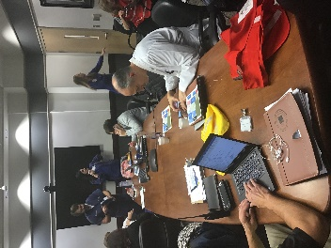
Objectives
During the exercise, the following objectives were exercised and evaluated:

- Objective #1 – UK Healthcare staff and admin will coordinate EMS transport arrangements to receive a person symptomatic with the Ebola virus disease for evaluation and preliminary treatment in accordance with Kentucky’s Ebola Response Plan.
UK’s ICS Briefing
- Objective #2 - UK Healthcare staff’s will transfer a patient confirmed with the Ebola virus disease to a designated treatment facility within an appropriate time frame as designated by the Implementation Guidance for Ebola Preparedness Measures.
- Objective #3 – Evaluate Lexington EMS procedures for the transport of a confirmed Ebola Virus patient to a treatment facility according to adopted infectious disease protocols.
- Objective #4 – UK Healthcare will notify and communicate with local, state, and federal ESF#8 partners in regards to patient assessment, treatment, and recommended transportation for an Ebola Virus patient as outlined in Kentucky’s Ebola Response plan.

- Objective #5 – Evaluate UK medical staff and EMS planning efforts for risk mitigation (e.g., biosafety containment and management with an emphasis on waste management) according to NETEC Ebola Assessment Hospital Preparedness checklist when receiving a person of interests in transfer.
- Objective #6 – UK Healthcare will adhere to infection prevention and control practices while managing a patient with Ebola Virus according to the NETEC Ebola Assessment checklist throughout the duration of the incident.

Major Strengths
The major strengths identified during the Bluegrass Ebola Response Exercise were as follows:
- UK admitting screened the patient correctly and responded appropriately.
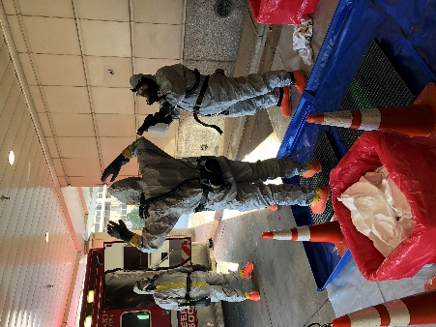
- Established relationships between UK and KDPH made information sharing smooth.
- UK was well prepared for conference calls and had established priorities.
- Coordination with FEMA Region IV REC was smooth and efficient.
- Communications from the UK EOC to other departments was well coordinated.
- Personal protection barriers in ED were quickly assembled.
- Facility Management team worked well in getting ante-rooms in ED and ICU.
Decon of EMS crew
- Frequent updates were provided by ICU to the ED to make sure they knew how the preparation to receive patient was progressing.

Primary Areas for Improvement
Throughout the response to the Bluegrass Ebola Response Exercise, several opportunities for improvement for participating agencies to respond and recover from the incident were identified. The primary areas for improvement are as follows:
- Doffing of clinical staff in triage and ED room.
- No environmental cleanup at admitting counter after patient presented. Patient was told to sit in waiting area.
- Cross contamination breaches by UK clinical staff while transferring the ED patient to bed for transport to ICU.
- Message left by Fayette Co Epidemiologist on State reporting line was improperly handed off to Preparedness Branch SHOC.
- UK Security rode in elevator with patient wearing no PPEs.
- Multiple contamination breaches by EMS during transfer of patient from ICU to EMS unit.
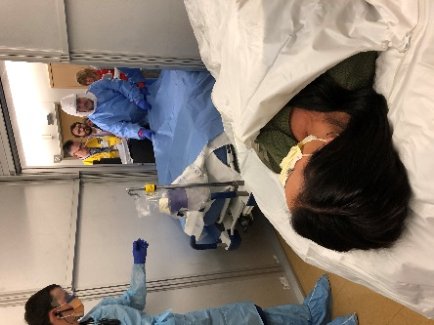
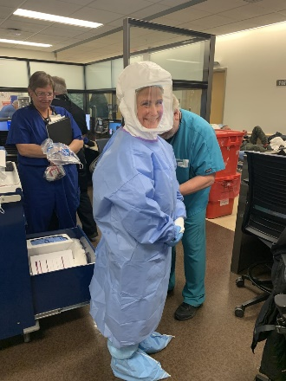
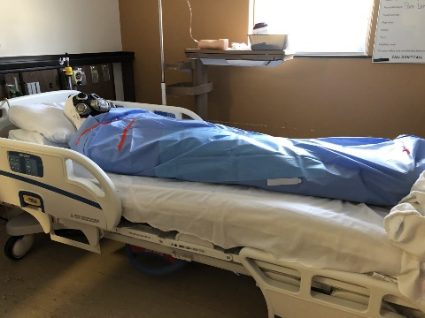
Ebola patient prepped for ICU transition
UK Nurse donned and ready
Ebola patient ready for transport

Conclusion
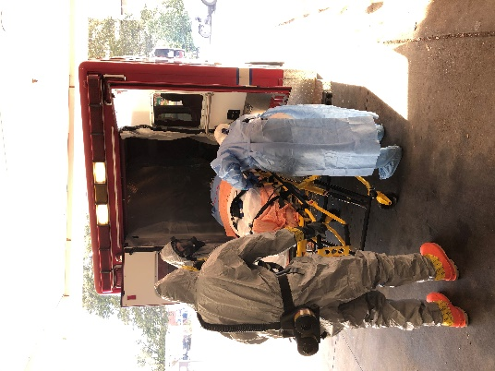
Overall, the response and recovery efforts of participating agencies and organizations were successful in managing, treating, transferring, and transporting a confirmed Ebola virus disease patient to Emory University Hospital in Atlanta, GA. Communication and information sharing between all agencies was well performed and coordinated. UK and Lexington Fire demonstrated proficient capabilities in handling an Ebola confirmed patient. Communication between UK Healthcare departments was seamless which facilitated easier coordination with agency personnel. KDPH’s SHOC, through coordination with the HHS Region IVREC and Georgia Department of Public Health, effectively provide assistance and technical support between all partners involved in the exercise. Continued planning efforts are still ongoing by local, state, and federal healthcare partners to effectively manage highly infectious disease patients. The outcomes identified from this exercise will enhance regional response coordination and capabilities in the future. Overall, the exercise was successful and well handled by UK Healthcare’s clinical staff, Lexington EMS, KDPH, and FEMA Region IV REC.
Patient being loaded by EMS and taken to Bluegrass Airport

Exercise Overview
Exercise Name | Bluegrass Ebola Response
Exercise Dates | Nov. 13th 2019
Scope | This exercise is a Full-Scale Exercise (FSE) that will be conducted in Lexington, KY on Nov. 13th 2019. In addition, Kentucky Dept for Public Health (KDPH) will provide coordination support with Georgia Dept of Health and Department of Health and Human Services (HHS) in Atlanta, GA. Play is limited to Bluegrass Healthcare Coalition (HCC) partners and support ESF-8 agencies. Exercise will begin at 9:00 am EST and conclude by 3:00 pm EST.
Mission Area(s) | Protection and Response
Core Capabilities | Foundation for Health Care and Medical Readiness, Health Care and Medical Response Coordination, Continuity of Health Care Service Delivery, and Medical Surge.
Objectives | 1. UK Healthcare staff and admin will coordinate emergency medical service transport arrangements to receive a person symptomatic with the Ebola virus disease for evaluation and preliminary treatment in accordance with Kentucky’s Ebola Response Plan.  2. UK Healthcare staff’s will transfer a patient confirmed with the Ebola virus disease to a designated treatment facility within an appropriate time frame as designated by the Implementation Guidance for Ebola Preparedness Measures.  3. Evaluate Lexington EMS procedures for the transport of a confirmed Ebola Virus patient to a treatment facility according to adopted infectious disease protocols.  4. UK Healthcare will notify and communicate with local, state and federal ESF-8 partners in regards to patient assessment, treatment and recommended transportation for an Ebola Virus patient as outlined in Kentucky’s Ebola Response plan.  5. Evaluate UK medical staff and EMS planning efforts for risk mitigation (e.g., biosafety containment and management with an emphasis on waste management) according to National Ebola Training and Education Center (NETEC) Ebola Assessment Hospital Preparedness checklist when receiving a person of interests in transfer.  6. UK Healthcare will adhere to infection prevention and control practices while managing a patient with Ebola Virus according to the NETEC Ebola Assessment checklist throughout the duration of the incident.
Threat or Hazard | Biological
Scenario | A person of interests (POI) will enter UK Medical Center that has returned from Democratic Republic of Congo after providing clinical support for Ebola patients. The patient will be isolated and accessed for a possible Ebola virus confirmation. Patient will then be prepped and transported by fixed wing aircraft from Bluegrass Airport to Emory University Medical Center for treatment.
Sponsor | UK Medical Center, KDPH and Bluegrass HCC
Participating Organizations | Local: UK Medical Center, Lexington Fire/EMS, Lexington Fayette Co Health Dept, Bluegrass HCC, Bluegrass Airport  State: KDPH, Georgia Department for Health  Federal: Department for Health and Human Services – Assistant Secretary for Preparedness and Response.  Reference Appendix B for complete list of exercise participants
Point of Contact | Dave Carney Regional Preparedness Coordinator Kentucky Department for Public Health 400 Professional Drive Winchester, KY 40391 Phone: (502) 905-9969 Email: davidn.carney@ky.gov Derek Forster, MD Infection Prevention MD UK Healthcare 800 Rose Street Lexington, KY 40536 Phone: (502) 554-3407 Email: derek.forster@uky.edu  Kim Blanton, MSN, MHA, RN, NE-BC CV Nursing Operations Administrator & Enterprise Director Infection Prevention & Control UK Healthcare 800 Rose Street Lexington, KY 40536 Phone: (859) 323-8660 Email: kblanton3@uky.edu Sharon Berry, RN CIC Director, Safety and Emergency Management UK Healthcare 800 Rose Street Lexington, KY 40536 Phone: (859) 323-5734 Email: sharon.berry@uky.edu  Rachel Howard, MSN, RN, CIC  Enterprise Manager Infection Prevention & Control  Manager Vascular Access Team  UK Healthcare  800 Rose Street  Lexington, KY 40536  Phone: (859) 323-6337  Email: rhowa2@uky.edu

Analysis of Core Capabilities
Aligning exercise objectives and core capabilities provides a consistent taxonomy for evaluation that transcends individual exercises to support preparedness reporting and trend analysis. Table 1 includes the exercise objectives, aligned core capabilities, and performance ratings for each core capability as observed during the exercise and determined by the evaluation team.

Table 1. Summary of Core Capability Performance
Exercise Objective | Core Capability
1 UK Healthcare staff and admin will coordinate emergency medical service transport arrangements to receive a person symptomatic with the Ebola virus disease for evaluation and preliminary treatment in accordance with Kentucky’s Ebola Response Plan. | Health and Medical Response Coordination
2 UK Healthcare staff’s will transfer a patient confirmed with the Ebola virus disease to a designated treatment facility within an appropriate time frame as designated by the Implementation Guidance for Ebola Preparedness Measures. | Health and Medical Response Coordination
3 Evaluate Lexington EMS procedures for the transport of a confirmed Ebola Virus patient to a treatment facility according to adopted infectious disease protocols. | Medical Surge  Continuity of Health Care Service Delivery  Health Care and Medical Response Coordination
4 UK Healthcare will notify and communicate with local, state and federal ESF #8 partners in regards to patient assessment, treatment and recommended transportation for an Ebola Virus patient as outlined in Kentucky’s Ebola Response plan. | Health and Medical Response Coordination
5 Evaluate UK medical staff and EMS planning efforts for risk mitigation (e.g., biosafety containment and management with an emphasis on waste management) according to NETEC Ebola Assessment Hospital Preparedness checklist when receiving a person of interests in transfer. | Foundation for Health Care and Medical Readiness.
6 UK Healthcare will adhere to infection prevention and control practices while managing a patient with Ebola Virus according to the NETEC Ebola Assessment checklist throughout the duration of the incident. | Foundation for Health Care and Medical Readiness  Medical Surge

Ratings Definitions:
Performed without Challenges (P): The targets and critical tasks associated with the core capability were completed in a manner that achieved the objective(s) and did not negatively impact the performance of other activities. Performance of this activity did not contribute to additional health and/or safety risks for the public or for emergency workers, and it was conducted in accordance with applicable plans, policies, procedures, regulations, and laws.
Performed with Some Challenges (S): The targets and critical tasks associated with the core capability were completed in a manner that achieved the objective(s) and did not negatively impact the performance of other activities. Performance of this activity did not contribute to additional health and/or safety risks for the public or for emergency workers, and it was conducted in accordance with applicable plans, policies, procedures, regulations, and laws. However, opportunities to enhance effectiveness and/or efficiency were identified.
Performed with Major Challenges (M): The targets and critical tasks associated with the core capability were completed in a manner that achieved the objective(s), but some or all of the following were observed: demonstrated performance had a negative impact on the performance of other activities; contributed to additional health and/or safety risks for the public or for emergency workers; and/or was not conducted in accordance with applicable plans, policies, procedures, regulations, and laws.
Unable to be Performed (U): The targets and critical tasks associated with the core capability were not performed in a manner that achieved the objective(s).
The following sections provide an overview of the performance related to each exercise objective and associated core capability, highlighting strengths and areas for improvement.

Objective 1 - UK Healthcare staff and administration will coordinate emergency medical service transport arrangements to receive a person symptomatic with the Ebola virus disease for evaluation and preliminary treatment in accordance with Kentucky’s Ebola Response Plan.

Core Capability - Health and Medical Response Coordination

Strengths
The partial capability level can be attributed to the following strengths:
Strength 1: Patient admitting screening process was conducted efficiently. Suspected Ebola patient was quickly identified and staff responded correctly.
Strength 2: Facility maintenance staff was able to erect personal protection barriers in the ED quickly until room in ICU was ready for patient.
Strength 3: Communications among departmental staff and UK’s EOC was excellent. Administration staff received constant updates on patient movement and clinical assessment.

Areas for Improvement
The following areas require improvement to achieve the full capability level:

Area for Improvement 1: Not enough UK Security members present.
Reference: UK All-Hazards Emergency Operations plan.
Analysis: There was confusion on direction when patient was moved from ED to ICU. Hospital visitors were slightly alarmed to see individuals exiting elevator dressed in full PAPRs. More security was needed in hallways when patient was transferred between departments.

Objective 2 - UK Healthcare staff’s will transfer a patient confirmed with the Ebola virus disease to a designated treatment facility within an appropriate time frame as designated by the Implementation Guidance for Ebola Preparedness Measures.

Core Capability - Health and Medical Response Coordination

Strengths
The full capability level can be attributed to the following strengths:
Strength 1: Coordination with FEMA Region IV Regional Emergency Coordinator was smooth and efficient.
Strength 2: UK demonstrated excellent coordination with conference calls between local, state and federal agencies.
Strength 3: UK provided clear and detailed patient information for Regional Epidemiologist.

Areas for Improvement
No areas for improvement identified.

Objective 3 - Evaluate Lexington EMS procedures for the transport of a confirmed Ebola Virus patient to a treatment facility according to adopted infectious disease protocols.

Core Capability - Medical Surge, Continuity of Health Care Service Delivery, Health and Medical Response Coordination

Strengths
The partial capability level can be attributed to the following strengths:
Strength 1: Excellent eye to eye communication between patient and EMS crew.
Strength 2: EMS crew followed a detailed process in decontamination of ambulance after patient was moved to airport.
Strength 3: Total number of EMS crew that made contact with patient was 3. Ebola performance measure standard is 3 or less.

Areas for Improvement
The following areas require improvement to achieve the full capability level:
Area for Improvement 1: Multiple contamination breaches by EMS during transfer of patient from ICU to EMS unit.
Reference: Lexington Fire standard operating protocol for handling of Infectious Disease patient.
Analysis: EMS crew donned in PAPRs had cross contamination breaches, brushing up against doorways and hallways. No confirmation if environmental staff cleaned these areas after patient was moved.

Objective 4 - UK Healthcare will notify and communicate with local, state and federal ESF-8 partners in regards to patient assessment, treatment and recommended transportation for an Ebola Virus patient as outlined in Kentucky’s Ebola Response plan.

Core Capability - Health and Medical Response Coordination

Strengths
The partial capability level can be attributed to the following strengths:
Strength 1: UK activated their EOC and staffed appropriately to the level of needed personnel for the movement of the confirmed Ebola patient.
Strength 2: UK quickly notified Regional Epidemiologist after patient presented in ED.
Strength 3: UK responded efficiently with Federal movement requests and coordination of Ebola patient.

Areas for Improvement
The following areas require improvement to achieve the full capability level:
Area for Improvement 1: LFCHD Epidemiologist left message on State’s Epi reporting line of Ebola patient at UK Hospital. The message was improperly handed off to Preparedness Branch SHOC.
Reference: Kentucky’s Ebola Response Plan
Analysis: SHOC was offline due to unforeseen circumstances. Communications between the Epidemiology reporting line and SHOC was not fluid. No formal communication hand off method was discussed as a result of the SHOC being temporarily displaced.

Objective 5 - Evaluate UK medical staff and EMS planning efforts for risk mitigation (e.g., biosafety containment and management with an emphasis on waste management) according to NETEC Ebola Assessment Hospital Preparedness checklist when receiving a person of interests in transfer.

Core Capability – Foundation for Health Care and Medical Readiness

Strengths
The full capability level can be attributed to the following strengths:
Strength 1: Environmental standards were well followed after patient was moved from ICU to ED for transportation to Bluegrass Airport.
Strength 2: Donning and doffing checklist were well followed in clinical areas.
Strength 3: Patient movement and transfer area at Bluegrass Airport was predetermined with patient privacy in mind.

Areas for Improvement
No areas for improvement identified.

Objective 6 - UK Healthcare will adhere to infection prevention and control practices while managing a patient with Ebola Virus according to the NETEC Ebola Assessment checklist throughout the duration of the incident.

Core Capability - Foundation for Health Care and Medical Readiness, Medical Surge

Strengths
The partial capability level can be attributed to the following strengths:
Strength 1: Ebola patient was considered wet. Patient was placed in self-containment bag to control infection breaches.
Strength 2: Lab personnel responded appropriately in packaging lab draws after being activated by clinical staff.

Areas for Improvement
The following areas require improvement to achieve the full capability level:
Area for Improvement 1: Nurse doffed in room with patient while in triage and emergency department.
Reference: UK’s Standard Operating Protocol (SOP) for PPE donning and doffing.
Analysis: Donning of clinical staff should be performed outside of triage or treatment room to prevent cross contamination and ensure clinical staff safety.
Area for Improvement 2: Security personnel rode in elevator with patient upstairs to ICU with no PPEs in use.
Reference: UK’s SOP for PPE donning and doffing.
Analysis: Donning of all essential staff should be performed when in proximity of confirmed Ebola Virus patient.
Area for Improvement 3: Administration staff in patient admitting did not adhere to infection prevention standards after patient presented at counter.
Reference: UK’s SOP for Infection Control.
Analysis: Patient laid head down on admitting counter and then was told to back to waiting area until called. No environmental staff cleaned the counter and another patient came to the desk shortly after the suspected Ebola virus patient left.
- Improvement Plan
Core Capability | Issue/Area for Improvement | Corrective Action | Capability Element | Primary Responsible Organization | Organization POC | Start Date | Completion Date
Core Capability: Health and Medical Response Coordination | 1. Patient movement coordination | Not enough UK Security members present. | Planning | UK Healthcare | Kim Blanton Rachel Howard  Sharon Berry | 01/01/20 | 06/30/20
Core Capability: Health and Medical Response Coordination | 1. EMS Infection Control protocols | Multiple contamination breaches by EMS during transfer of patient from ICU to EMS unit. | Training | Lexington Fire/EMS | Adam Morgan  Rob Larkin  Edward Crews | 01/01/20 | 06/30/20
Core Capability: Health and Medical Response Coordination | 2. Communications | LFCHD Epi left message on State’s Epi reporting line of Ebola patient at UK Hospital. The message was improperly handed off to Preparedness Branch SHOC | Organization | Kentucky Dept for Public Health | Jasie Logsdon | 01/01/20 | 06/30/20
Core Capability Foundation for Health Care and Medical Readiness | 2. Infection Control Standards | Nurse doffed in room with patient while in triage and emergency department. | Training | UK Healthcare | Kim Blanton Rachel Howard  Sharon Berry | 01/01/20 | 06/30/20
Core Capability Foundation for Health Care and Medical Readiness | 1. Infection Control Standards | Security personnel rode in elevator with patient upstairs to ICU with no PPEs in use. | Training | UK Healthcare | Kim Blanton Rachel Howard  Sharon Berry | 01/01/20 | 06/30/20
Core Capability Foundation for Health Care and Medical Readiness | 1.Infection Control Standards | Administration staff in patient admitting did not adhere to infection prevention standards after patient presented at counter. | Training | UK Healthcare | Kim Blanton Rachel Howard  Sharon Berry | 01/01/20 | 06/30/20

**This IP has been developed specifically for all exercise players as a result of Bluegrass Ebola Response Exercise conducted on Nov. 13th, 2019.

Appendix B: Exercise Participants
Participating Organizations
Federal
FEMA Region IV Emergency Operations Coordinator
State
Kentucky Department for Public Health
Georgia Department of Health
Local
UK Healthcare
Lexington Fire EMS
Lexington Fayette County Health Department
Bluegrass Healthcare Coalition

Appendix C: Acronyms
ED | Emergency Department
EMS | Emergency Medical Services
EOC | Emergency Operations Center
ESF | Emergency Support Function
FSE | Full Scale Exercise
FEMA | Federal Emergency Management Agency
HCC | Health Care Coalition
HHS | Health & Human Services
ICU | Intensive Care Unit
KDPH | Kentucky Department for Public Health
NETEC | National Ebola Training & Exercise Center
POI | Person Of Interest
PPE | Personal Protective Equipment
REC | Regional Emergency Coordinator
SHOC | State Health Operations Center
SOP | Standard Operating Protocol
UK | University of Kentucky

Capability Elements are: Planning, Organization, Equipment, Training, or Exercise.

