MULTIYEAR TRAINING AND EXERCISE PLAN (MYTEP)

Bluegrass Healthcare Coalition

Budget Periods:
July 1, 2020 - June 30, 2022

This page is intentionally blank.

Administrative Handling Instructions

- The title of this document is [enter coalition name here] Health Care Coalition’s (HCC) Multiyear Training and Exercise Plan (MYTEP).

- This document should be safeguarded, handled, transmitted, and stored in accordance with appropriate security directives and should be released to individuals on a need-to-know basis. Information contained herein was prepared for the exclusive use of the HCC and other agencies that are responsible for emergency preparedness and response. Reproduction of this document, in whole or in part, without prior approval from the HCC is prohibited.

- For more information, please refer to the following points of contact (POCs):

Name: Dave Carney  Title: Regional Response Coordinator  Office: Clark Co Health Dept  Address:400 Professional Dr, Winchester 40391  Phone: (502) 905-9969  Email: DavidN.Carney@ky.gov | Name: Terri Schoebel  Title: Coalition Chair  Office: VA Medical Center - Leestown  Address: 2250 Leestown Rd, Lexington 40511  Phone: (859) 948-0425  Email: Terri.Montgomery@va.gov

Table of Contents

Administrative Handling Instructions iii
Table of Contents iv
Purpose 1
Appendix A: Multi-Year Training and Exercise Schedule A-1
Appendix B: Acronyms B-1

This page is intentionally blank.

Purpose

The purpose of this Multiyear Training and Exercise Plan (MYTEP) is to provide a roadmap for the Bluegrass Healthcare Coalition to follow in accomplishing the program priorities identified during the HCC’s annual Multiyear Training and Exercise Planning Workshop (MYTEPW). This plan is a supporting document to the Kentucky Department for Public Health’s (KDPH) Multiyear Training and Exercise Plan (MYTEP).

This MYTEP is a living document that will be updated annually and be submitted to meet the annual Hospital Preparedness Program (HPP) reporting requirements as listed in federal guidance documents, KDPH’s Preparedness Branch Strategic Plan, and the current Kentucky Regional Healthcare Coalition (HCC) Regional Grant and Spending Plan Guidance.

Included in the MYTEP is a training and exercise schedule which provides graphic illustration of proposed training and exercise activities for the period of July 1, 2020 to June 30, 2022. It is representative of the natural progression of training and exercises that should take place in accordance with the building-block approach.

HCCs are encouraged to develop the MYTEP in coordination with local, regional and state planning partners. During the planning process, HCCs should reference the KDPH MYTEP and consider additional state/federal requirements, potential threats, vulnerabilities, baseline levels of preparedness and/or exercise needs.

Appendix A: Multiyear Training and Exercise Schedule
Appendix A contains a graphic illustration of proposed training and exercise activities for [enter coalition name here] HCC from July 1, 2019 to June 30, 2021. This schedule portrays both training and exercises that correspond to the program priorities as identified state and federal guidance.
Year
Month/Quarter

July

Aug

Sep

Oct

Nov

Dec

Jan

Feb

Mar

Apr

May

June
2020

￼￼

￼

2021

2022

RWE—COVID –19 Response
FSE – COVID19 Response
FSE – COVID19 Response
EARTH EX—200
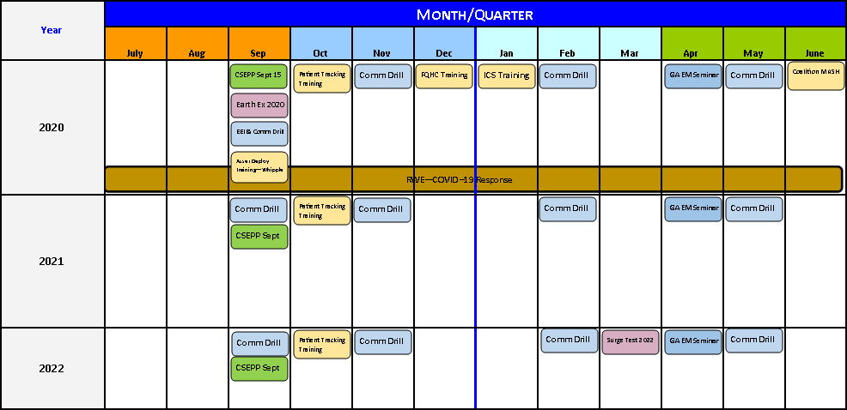

Training | Seminar | Workshop | Tabletop | Game | Drill | Functional | Full-Scale | Real-World
TRN | SEM | WSH | TTX | GME | DRL | FE | FSE | RWE

Appendix B: Acronyms
Acronym | Title
DRL | Drill
FE | Functional Exercise
FSE | Full-Scale Exercise
GME | Game
HCC | Healthcare Coalition
HPP | Hospital Preparedness Program
MS | Medical Surge
POC | Point of Contact
SEM | Seminar
TEP | Training and Exercise Plan
TRN | Training
TTX | Tabletop Exercise
WSH | Workshop

