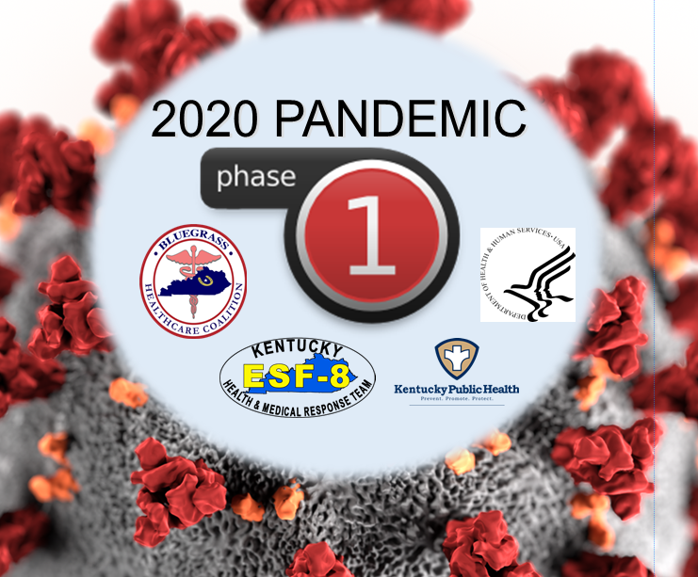

Region 15 Regional Response

Center Coordination

COVID19 Pandemic Response – Phase 1
  - After-Action Report/Improvement Plan
July 1st 2020

Overview
Event Name | Region 15 Regional Response Center Coordination (RRCC) – COVID19 Pandemic Response Phase 1
Dates | Activation of RRCCs occurred in March 2020 and continued through July 2020. A de-escalation of the RRCC occurred in the fall the response to healthcare partner continued into 2021.
Scope | This AAR covers the response to Phase 1 of the COVID Pandemic and response support to Region 15 and its healthcare partners.
Mission Area(s) | Response and Recovery
Objectives | 1. R15-RRCC will provide up-to-date and factual situational awareness information to healthcare partners in response to the COVID19 Pandemic.  2. R15-RRCC will act as a liaison between regional healthcare partners and state public health response agencies involved with the COVID19 Pandemic.  3. R15-RRCC will assist in supplying healthcare with needed assets and materials in response to the COVID19 Pandemic.
Threat or Hazard | COVID-19 Pandemic
Synopsis | Upon initial confirmation regarding Kentucky’s first positive COVID case which was located in Harrison County, the state activated the State Health Operations Center and subsequently Regional Response Coordination Centers across the Commonwealth. Information on how to respond to the onset of COVID cases was crucial. RRCCs expanded the State’s capacity to support regional partners with necessary information and needed resources.
Participating Organizations | Kentucky Dept for Public Health Emergency Preparedness Region 15W  Kentucky Dept for Public Health Emergency Preparedness Region 15E  Bluegrass Healthcare Coalition  Kentucky Dept for Public Health Regional Epidemiologists  Regional Healthcare Partners
Point of Contact | Dave Carney, MS, MEP Regional Response Coordinator Kentucky Department for Public Health 400 Professional Drive Winchester, KY 40391 Phone: (502) 905-9969 Email: davidn.carney@ky.gov Rebecca L Hardin, CHES Regional Preparedness Coordinator Region 15W Kentucky Department for Public Health 448 South 3rd St Danville, KY 40422 Phone: (502) 352-8319 Email: rebeccaL.hardin@ky.gov  Kim Yazell RPC / Community Section Supervisor Kentucky Department for Public Health 210 E Walnut Street Nicholasville, KY 40356 Phone: (502) 229-5573 Email: kimd.yazell@ky.gov Vicki Sanderson Regional Preparedness Coordinator Region 15E Kentucky Department for Public Health 115 Cisco Rd Lexington, KY 40504 Phone: (502) 352-8263 Email: vicki.sanderson@ky.gov

Executive Summary
Initial news reports established the spread of COVID-19 cases was occurring within the United States in late January of 2020 into early February. Chinese officials were attempting to place restrictions on travel due to multiple cases being reported but the virus had already subsequently found its way into the US.
On March 6th 2020, Governor Beshear held a press conference and announced Kentucky’s first confirmed COVID-19 case. The patient was admitted to a Lexington hospital where they were being treated and isolated. Later it was disclosed this person was an employee who worked at a Wal-Mart in Harrison County. The individual had no travel history. No connection was made to how this person became infected with the virus. Governor Beshear instituted a state of emergency and Kentucky Emergency Management activated the state’s emergency operation’s center to level 1.
Following this initial report other cases started to become more widespread across the state. Local health departments activated their emergency operations center and initiated contact tracing surveillance. Much was not known concerning information on COVID-19. Additional guidance was needed from the State’s Public Health system.
Regional Response Coordination Centers (RRCC) were activated and regional staff assisted in providing local health departments and hospitals with current information as it became available. Contacting tracing revealed the virus was highly contagious and isolating individuals was crucial to prevent further spread. The virus proved to have a far greater impact on individuals with chronic issues and elderly. Some individuals with far more severe symptoms required hospitalization. Much was not known how to effectively provide treatment.
Our RRCC continued to provide information with stakeholders as it became available. PPE shortages throughout the hospital chains became critically low. Resources were requested from the State’s PPE cache to help fill in shortages. The Strategic National Stockpile (SNS) released additional PPE from its warehouse chain to resupply state warehouses as more and more cases were starting to populate the Commonwealth.
During the writing of this after action report the pandemic response has continued. It was strongly encouraged for healthcare partners to determine strengths and weaknesses during the initial phase of the pandemic. A survey was sent by our RRCC team to regional partners so that input could be recorded of strengths and weaknesses. The following items were determined to be the realized strengths:
- Weekly RRCC phone calls  - Regional Distribution Warehouse  - State COVID-19 website  - Governor’s support and response | - Local Public Health support  - State DPH support  - PPE request  - Regional sit rep  - Regional Response Coordination Center

The following items were determined to be the realized gaps:
- Clear funding guidance  - Information distribution process  - COVID-19 compliance guidelines  - Transportation needs for patients | - Access to testing supplies  - Congregant center access  - PPE request process
RRCCs deescalated to a monitoring status in late August of 2020. Our regional response team moved to operating virtually while continuing to support our healthcare partners by providing current information and conveying additional needs to the state.

Objective 1. R15-RRCC will provide up-to-date and factual situational awareness information to healthcare partners in response to the COVID19 Pandemic.

Strengths
Strength 1: Weekly RRCC phone calls.
Strength 2: Regional Situation Reports.
Strength 3: Governor’s support and response.

Areas for Improvement
The following areas require improvement:
Area for Improvement 1: During the initial response to the pandemic information from the state would often come late to partners responding to COVID positive patients. Information was not disseminated in a timely manner from the state into the region.
Reference: KDPH State Health Operation Center Support Plan, Bluegrass Healthcare Coalition Emergency Operations Plan.
Analysis: SHOC Support Plan - Assumptions page 8-2-2: Situational awareness and dissemination of public information will be maintained through defined information sharing processes and the use of communication and information technology (IT) systems in coordination with local, state, and federal agencies.
BGHCC EOP – Assumptions page 1-3-7- BGHCC partners will communicate their needs for coalition resources through the BGHCC Readiness and Response Coordinator (RRC).

Area for Improvement 2: Local Health Departments were trying to determine where to place individuals in congregant care areas. This was an initial issue due to individuals not able to isolate from other family members in their own home.
Reference: KDPH State Health Operation Center Support Plan, Bluegrass Healthcare Coalition Emergency Operations Plan.
Analysis: SHOC Support Plan - Assumptions page 8-2-2: Additional resources from local, state, interstate, and federal agencies will be needed to supplement and assist impacted jurisdictions to ensure continuity of medical and public health services. ESF#8 Resource Request Flowchart.
BGHCC EOP – Assumptions page 1-3-7- BGHCC partners will communicate their needs for coalition resources through the BGHCC Readiness and Response Coordinator (RRC).

Objective 2. R15-RRCC will act as a liaison between regional healthcare partners and state public health response agencies involved with the COVID19 Pandemic.

Strengths
Strength 1: Regional Resource Response Center.
Strength 2: State Department of Public Health support.
Strength 3: State Emergency Management response.
Strength 4: Healthcare Coalition support.

Areas for Improvement
The following areas require improvement:
Area for Improvement 3: Health departments needing clear funding guidance so they could properly track expenses during the pandemic.
Reference: KDPH State Health Operation Center Support Plan, Bluegrass Healthcare Coalition Emergency Operations Plan.
Analysis: SHOC Support Plan - Assumptions page 8-2-2: Situational awareness and dissemination of public information will be maintained through defined information sharing processes and the use of communication and information technology (IT) systems in coordination with local, state, and federal agencies.
BGHCC EOP – Assumptions page 1-3-7- BGHCC partners will communicate their needs for coalition resources through the BGHCC Readiness and Response Coordinator (RRC).

Objective 3. R15-RRCC will assist in supplying healthcare with needed assets and materials in response to the COVID19 Pandemic.
Strength 1: PPE request process.
Strength 2: Local Public Health support.
Strength 3: Regional Distribution Warehouse.
Strength 4: State Warehouse PPE supplies.

Areas for Improvement
The following areas require improvement:
Area for Improvement 4: Healthcare agencies began to encounter a lack of PPE supplies and testing products. Supply chains were at their limits and while some larger healthcare agencies were able to have more buying power than smaller healthcare partners.
Reference: KDPH State Health Operation Center Support Plan, Bluegrass Healthcare Coalition Emergency Operations Plan.
Analysis: SHOC Support Plan - Assumptions page 8-2-2: Additional resources from local, state, interstate, and federal agencies will be needed to supplement and assist impacted jurisdictions to ensure continuity of medical and public health services. ESF#8 Resource Request Flowchart.

BGHCC EOP – Assumptions page 1-3-7- Local resources will be utilized first; however, a disaster or emergency incident may burden and/or overwhelm the health and medical infrastructure. This increase in demand may require a regional, state or federal response.

Area for Improvement 5: Non-emergency medical transportation was an issue. Transport companies did not want to expose employees to COVID positive patients. This created an issue with transporting COVID positive individuals to dialysis treatment centers.
Reference: KDPH State Health Operation Center Support Plan, Bluegrass Healthcare Coalition Emergency Operations Plan.
Analysis: SHOC Support Plan - Assumptions page 8-2-2: KDPH will coordinate ESF 8 - Public Health and Medical Services through the SHOC to support any incident/event that may occur within the Commonwealth of Kentucky, FEMA Region IV, or neighboring states.
BGHCC EOP – Assumptions page 1-3-7-BGHCC partners will communicate their general Emergency Support Function #8 (ESF-8) needs to the appropriate jurisdictional Emergency Management Agency – Emergency Operations Center (EOC).

- Improvement Plan
Issue/Area for Improvement | Corrective Action | Capability Element | Primary Responsible Individual/Entity | Individual/Entity POC | Start Date | Completion Date
1. During the initial response to the pandemic information from the state would often come late to partners responding to COVID positive patients. Information was not be disseminated in a timely manner from the state into the region. | Lessons learned from the current pandemic will generate realized gaps for local and state agencies. This will enable better planning to shorten the time when information is needed at the local level. | Planning | KDPH  BGHCC | RRCC Team  Dave Carney | 01/01/2021 | 06/31/2021
2. Local Health Departments were trying to determine where to place individuals in congregant care areas. This was an initial issue due to individuals not able to isolate from other family members in their own home. | Local agencies were able to locate hotels that would isolate individuals who needed to be quarantined. The State was able to open congregant care sites in through the State Park system to house these individuals. | Planning | KDPH / Local agencies | RRCC Team | 01/01/2021 | 06/31/2021
3. Health departments needing clear funding guidance so they could properly track expenses during the pandemic. | Cost centers needed to be established early to code expenses. This was later realized and established for LHDs. Special funding was also acquired and information was disseminated to LHDs. | Planning | KDPH | RRCC Team | 01/01/2021 | 06/31/2021
4. Healthcare agencies began to encounter a lack of PPE supplies and testing products. Supply chains were at their limits and while some larger healthcare agencies were able to have more buying power than smaller agencies. | After the Governor declared a state of emergency, SNS supplies were released and distributed to all states to eliminate the gaps. The amount of supplies needed was never a realized issue until this pandemic exposed the need. | Equipment | KDPH  BGHCC | RRCC Team  Dave Carney | 01/01/2021 | 06/31/2021
5. Non-emergency medical transportation was an issue. Transport companies did not want to expose employees to COVID positive patients. This created an issue with transporting COVID positive individuals to dialysis treatment centers. | The transportation later realized it was possible to transport patients for medical treatment without placing their employees in harms way. The Coalition was able to acquire isolation devices so EMS could safely transport these individuals. | Training / Exercise | BGHCC | Dave Carney | 01/01/2021 | 06/31/2021

**This IP has been developed specifically for the Bluegrass Healthcare Coalition as a result of Earth Ex 2020 that occurred on September 24th, 2020.

Appendix B: Acronym List
Acronym/Abbreviation | Definition
AAR | After Action Report
RRCC | Regional Response Coordination Center
EOC | Emergency Operations Center
SHOC | State Health Operations Center
BGHCC | Bluegrass Healthcare Coalition

Appendix C: Region 15 Regional Response Coordination Team Members
Name | Agency
Dave Carney – Regional Response Coordinator | Kentucky Dept for Public Health
Rebecca Hardin – Region 15W – Regional Preparedness Coordinator | Kentucky Dept for Public Health
Vicki Sanderson – Region 15E – Regional Preparedness Coordinator | Kentucky Dept for Public Health
Kim Yazell – Regional Preparedness Coordinator Supervisor | Kentucky Dept for Public Health
Quantez Crowe – Bluegrass Region Epi | Kentucky Dept for Public Health
Rudrani Ghost – Capital Region Epi | Kentucky Dept for Public Health

Capability Elements are: Planning, Organization, Equipment, Training, or Exercise.

