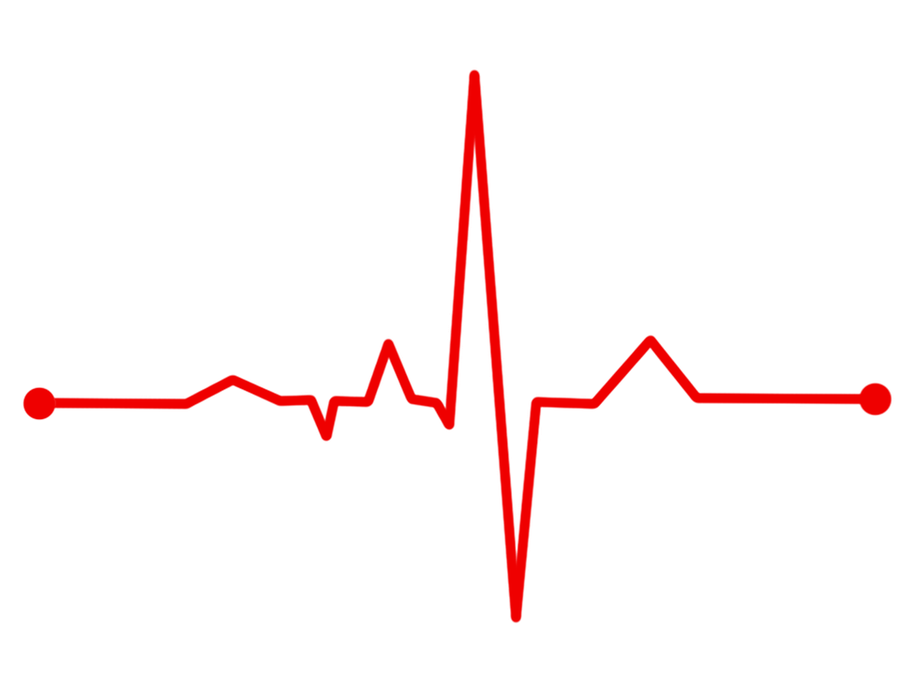

Earth Ex 2020 – Bluegrass

Healthcare Coalition
  - After-Action Report/Improvement Plan
  - Sept 24th, 2020

Overview
Event Name | Earth Ex 2020 – Bluegrass Healthcare Coalition
Dates | Scheduled for Sept.24th 2020 for the duration of 2 hours. Extent of play intended for the Bluegrass Healthcare Coalition Executive team.
Scope | This AAR covers the response to Earth Ex 2020 – Bluegrass Healthcare Coalition Executive team within HPP region 5 and its partners.
Mission Area(s) | Response and Recovery
Objectives | - Improve community resilience to long-duration power outages and Black Sky events through cross-sector planning, training, and exercises.  - To provide an opportunity to test and refine policies and procedures for responding to an extended duration power outage.  - To provide an opportunity to facilitate Critical Lifeline Cross-Sector discussions.  4. To provide a widely distributed, interactive, multi-language  international exercise using new DHS exercise tools.
Threat or Hazard | Electromagnetic Pulse – Power grid interruption.
Synopsis | Widespread regional EMP attack impacts in Phase 1 and a worldwide cyberattack in Phase 2. These threats result in bringing down the grid, including the cross-sector cascading impacts to infrastructure dependent on power and communities as well as the public due to a long-term power loss.
Participating Organizations | Bluegrass Healthcare Coalition
Point of Contact | Dave Carney, MS, MEP  Regional Response Coordinator  Kentucky Department for Public Health  400 Professional Drive  Winchester, KY 40391  Phone: (502) 905-9969  Email: davidn.carney@ky.gov

Executive Summary
EARTH EX 2020 Framing Background – The exercise takes place in a world with a high volume of volatility politically, militarily, and economically, leading to a destabilized environment where taking information at face value may be a mistake. Each individual and organization must take responsibility for their protection and survival. Traditional relationships have eroded for a variety of reasons, and nefarious nation-state actors are working just behind the scenes to advance their objectives.

Phase 1 Back Story – While most of the world is focused on survival and continuing to build economies back to pre-COVID levels, other actors see this as a perfect opportunity. Their goal is to entirely destabilize modern societies and inflict additional uncertainty into an already fragile world order. Forces unnamed that now acquired the potential to cause a high-level of panic by introducing a new Black Sky threat that most people, and nearly no governments, are adequately prepared to address. Citizens around the globe are concerned with what information is accurate and can be trusted. This situation tests leaders at all levels.

Phase 2 Back Story – Widespread attacks on the elements of the society that support the functioning of nearly one hundred percent of the global economy are targets in a series of what appears to be unconnected cyber-attacks in the form of bitcoin hacks. These cyber-attacks, up until recently, seemed disconnected and random. Cyberattacks and ransomware attacks on specific sectors and geographic areas are building. Some will look like the ransomware attacks we observed last year across Texas. Others focus on the critical lifeline infrastructures and transportation networks like the Ukraine attacks.
These attacks now appear to be fronts or feints for organizations. They are using the cover of ransomware attacks to map networks and set botnets and triggerable software hacks to enable future attacks. While the attacks originally appeared to be a criminal enterprise activity, new intelligence indicates that these attacks may have the support of one or more nation-states. Due to the pervasive nature of attacks on critical organizations and lifeline utilities, the situation is dangerous. Public distrust is at an all-time high as citizens around the world are unsure of where to go for validated information to advance base plans and responses. Social media’s impact continues to polarize segments of the population. In this environment, politicians and government leaders do not seem to be prepared to organize a nationwide response to thwart these potential vulnerabilities. Individual and community leadership is critical to address the looming crisis. People need dependable, reliable information.

Phase 3 Back Story – The need for individual, organizational, national, and international continuity and contingency plans is paramount. Some of the systems that underpin the economic engines of modern society cannot function without broad agreement on infrastructure standards, including, but not limited to, finance, communications, security, and emerging threats. Considering the near Black Sky global pandemic COVID environment, the need to gather everyone’s best ideas on how to advance global resilience is essential. Phase 3 presents a likely advanced status from Phase 2 cyber catastrophe to support a robust discussion by all participants. Phase 3 ends with a backward reflection that addresses many of the global contingency areas where real progress is required.
The Bluegrass Healthcare Coalition considered vendor related services and essential medical services would be severely and catastrophically impacted. Our Executive members addressed the following mission critical areas to mitigate the impact of the electromagnetic pulse.
- Fuel supply  - Back up generators  - Equipment supporting care for critical patients  - Fuel supply | - Back up generators  - Equipment supporting care for critical patients  - Water supply  - Communications.

Objective 1. Improve community resilience to long-duration power outages and Black Sky events through cross-sector planning, training, and exercises.

Strengths
Strength 1: Provide direction and coordination in restoring power interruption to hospitals and essential medical services.
Strength 2: Work to develop a plan for the supply of water and food to those most impacted.
Strength 3: Look for support to ensure backup fuel supply reaches vendors or state coordinated response areas that supply essential medical provisions for hospitals.

Areas for Improvement
The following areas require improvement:
Area for Improvement 1: Reliable information and how it is delivered to coalition partners will be critical. An EMP would severely impact communication equipment. The Bluegrass Healthcare Coalition sees this as a significant liability that hamper efforts to communicate with partners.
Reference: Bluegrass Healthcare Coalition Emergency Operations plan

Objective 2. To provide an opportunity to test and refine policies and procedures for responding to an extended duration power outage.

Strengths
Strength 1: Ensuring conservation policies are in place.
Strength 2: Addressing interruptions to pharmaceuticals for all hospitals, nursing homes and personal care.
Strength 3: Providing critical communication for partners.

Areas for Improvement
The following areas require improvement:
Area for Improvement 2: Individuals who work for any healthcare agency would experience significant disruptions to transportation and stabilization with impacts with conditions in their homes. Human resources will be impacted and severely limited. It will be imperative for all essential medical workers to have provisions in place to endure long work periods.
Reference: Local agency COOP plans.
Objective 3. To provide an opportunity to facilitate Critical Lifeline Cross-Sector discussions.

Strengths
Strength 1: Proper direction and authorization to establish Crisis Standards of Care protocols.
Strength 2: Emergency management response and ESF8 support.
Strength 3: Declaration of an emergency to release federal support and supplies.

Areas for Improvement
The following areas require improvement:
Area for Improvement 3: Most acute care hospitals have never addressed critical thinking in Crisis Standards of Care. This may have been addressed in Emergency Operation plans but more than likely not well communicated with medical staff.
Reference: Crisis Standards of Care plans, locally and state plans.

Objective 4. To provide a widely distributed, interactive, multi-language international exercise using new DHS exercise tools.

Strengths
Strength 1: Provided the necessary tools for critical thinking.
Strength 2: Challenged current plans to enable participants to consider back to basic mentality.
Strength 3: No fault environment to test systems for widespread power outages.

Areas for Improvement
The following areas require improvement:
No areas for improvement observed.

- Improvement Plan
Issue/Area for Improvement | Corrective Action | Capability Element | Primary Responsible Individual/Entity | Individual/Entity POC | Start Date | Completion Date
1. Reliable information and how it is delivered to coalition partners will be critical. An EMP would severely impact communication equipment. The Bluegrass Healthcare Coalition sees this as a significant liability that hamper efforts to communicate with partners. | Develop plans for more reliable redundant communications. | Planning / Equipment | BGHCC | Dave Carney | 12/01/2021 | 06/31/2021
2. Individuals who work for any healthcare agency would experience significant disruptions to transportation and stabilization with impacts with conditions in their homes. Human resources will be impacted and severely limited. It will be imperative for all essential medical workers to have provisions in place to endure long work periods. | Access provisions for human resources to mitigate the response to severely impacted personnel shortages. | Planning | BGHCC | Dave Carney | 12/01/2021 | 06/31/2021
3. Most acute care hospitals have never addressed critical thinking in Crisis Standards of Care. This may have been addressed in Emergency Operation plans but more than likely not well communicated with medical staff. | Communicate and train medical personnel in Crisis Standards of Care best practices. | Training | BGHCC | Dave Carney | 12/01/2021 | 06/31/2021

**This IP has been developed specifically for the Bluegrass Healthcare Coalition as a result of Earth Ex 2020 that occurred on September 24th, 2020.

Appendix B: Acronym List
Acronym/Abbreviation | Definition
AAR | After Action Report
HSEEP | Homeland Security Exercise Evaluation Program
IP | Improvement Plan
POC | Point of Contact
BGHCC | Bluegrass Healthcare Coalition

Appendix C: BGHC Executive Team Participants
Name | Agency
Freeman Bailey | Woodford County EMS
BJ Newberry | WeKare Healthcare Coalition
Vicki Sanderson | Kentucky Dept for Public Health
Terri Schoebel | VA Medical Center
Michael Hennigan | Scott Co Emergency Management
Rebecca Hardin | Kentucky Dept for Public Health
Darcy Maupin | St. Joseph Berea
Tara Long | Baptist Health Richmond
Dave Carney | Kentucky Dept for Public Health

Capability Elements are: Planning, Organization, Equipment, Training, or Exercise.

